

***Assignment 1***

***Muhammad Rafay***

***20P-0018***

***Computer Networks***

***Sec A***

**Setting Router Name**

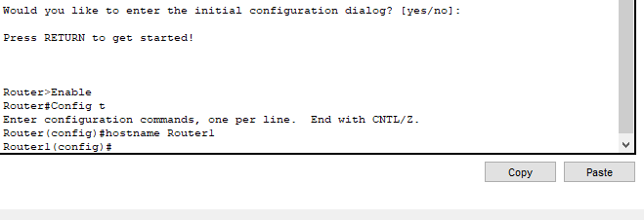

**Clock Set & Date/Time**

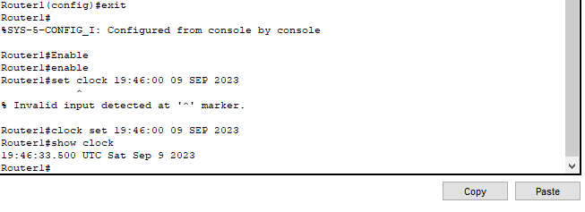

**Setting Banner**

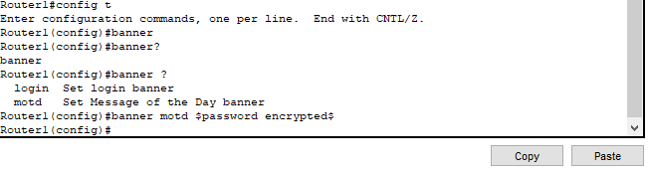

**Configurations Running**

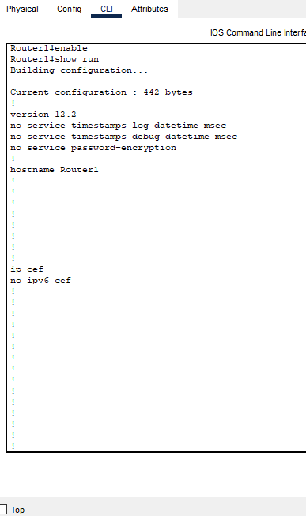

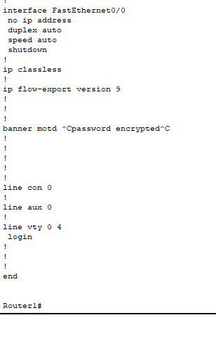

**Enable Password.**



**Secret Password without Encryption**

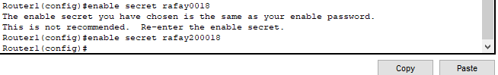

**Now Applying encryption technique md5 of level 8**

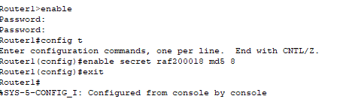

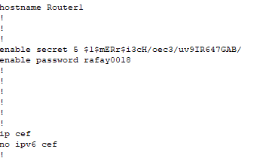

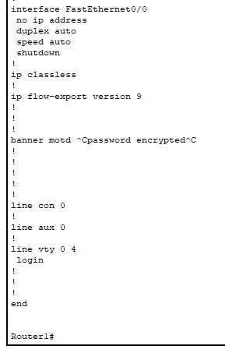

**TOPOLOGY**

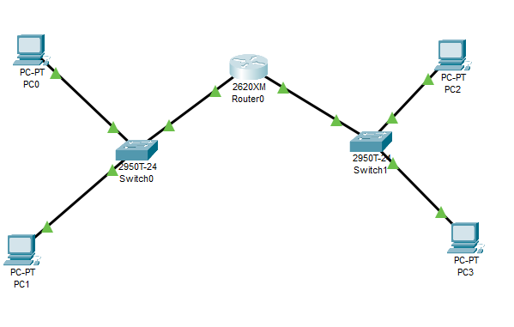

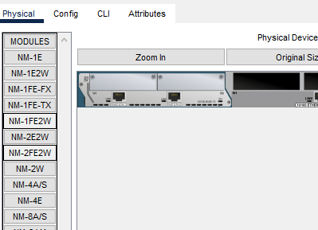

Using NM-2FE2W to add two additional Ethernet Ports as there is only one port avaible in series 2600 router by default.